**ASSIGNMENT 3**

1)

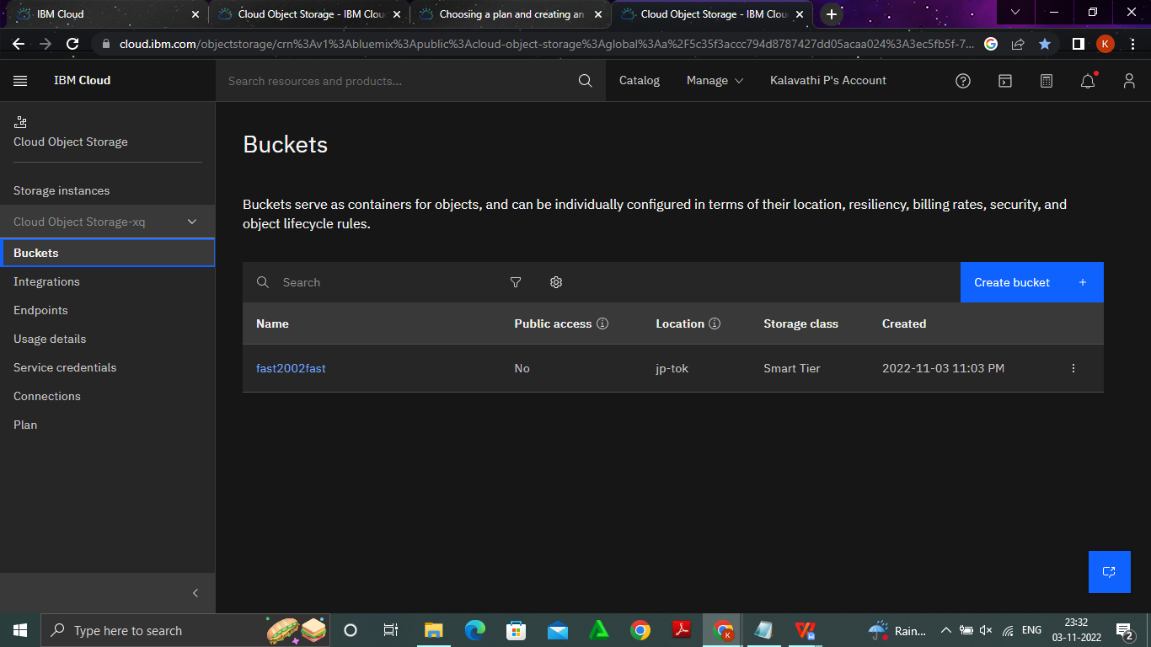

**2)**

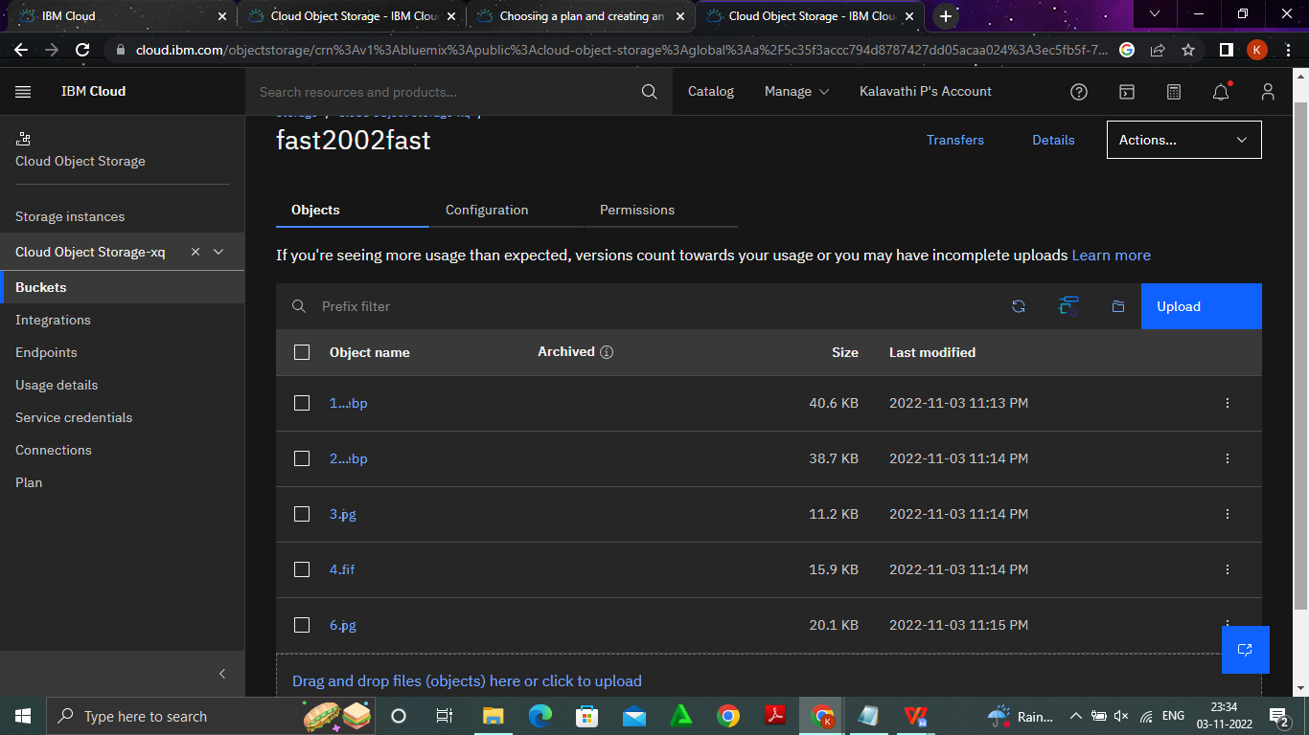

<!DOCTYPE html>

<html lang="en">

<head>

<meta charset="UTF-8">

<meta http-equiv="X-UA-Compatible" content="IE=edge">

<meta name="viewport" content="width=device-width, initial-scale=1.0">

<title>Document</title>

<link rel="stylesheet" href="https://sbka21.s3.us-east.cloud-object

storage.appdomain.cloud/style.css">

</head>

<body>

<img src="https://sbka21.s3.us-east.cloud-object

storage.appdomain.cloud/img1.jpg" alt="">

<img src="https://sbka21.s3.us-east.cloud-object

storage.appdomain.cloud/img2.jpg" alt="">

<img src="https://sbka21.s3.us-east.cloud-object

storage.appdomain.cloud/img3.jpg" alt="">

<img src="https://sbka21.s3.us-east.cloud-object

storage.appdomain.cloud/img5.jpg" alt="">

<img src="https://sbka21.s3.us-east.cloud-object

storage.appdomain.cloud/img4.jpg" alt="">

</body>

</html>

**3)**

img{

text-align: center;

height:250px;

width:250px;

}

<!DOCTYPE html>

<html lang="en">

<head>

<meta charset="UTF-8">

<meta http-equiv="X-UA-Compatible" content="IE=edge">

<meta name="viewport" content="width=device-width, initial

scale=1.0">

<title>Document</title>

<link rel="stylesheet" href="https://sbka21.s3.us-east.cloud-object

storage.appdomain.cloud/style.css">

</head>

<body>

<img src="https://sbka21.s3.us-east.cloud-object

storage.appdomain.cloud/img1.jpg" alt="">

<img src="https://sbka21.s3.us-east.cloud-object

storage.appdomain.cloud/img2.jpg" alt="">

<img src="https://sbka21.s3.us-east.cloud-object

storage.appdomain.cloud/img3.jpg" alt="">

<img src="https://sbka21.s3.us-east.cloud-object

storage.appdomain.cloud/img5.jpg" alt="">

<img src="https://sbka21.s3.us-east.cloud-object

storage.appdomain.cloud/img4.jpg" alt="">

</body>

</html>

**4)**

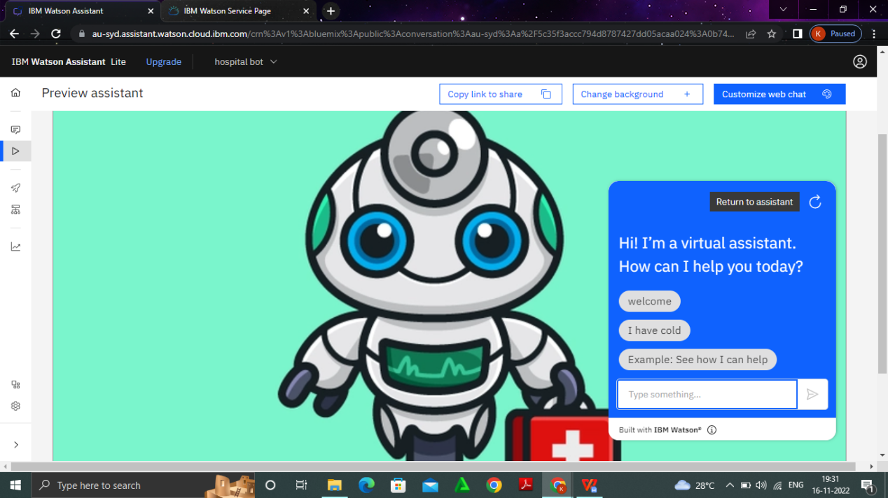

https://web-chat.global.assistant.watson.appdomain.cloud/preview.html?backgroundImageURL=https%3A%2F%2Fau-syd.assistant.watson.cloud.ibm.com%2Fpublic%2Fimages%2Fupx-0b7493ce-89d5-4d38-ae79-dca9922dd1ac%3A%3Aa23b1179-cc73-420f-8f9c-e3412ce05faa&integrationID=0817017a-0ee8-430a-9531-5ee77a6d7d78&region=au-syd&serviceInstanceID=0b7493ce-89d5-4d38-ae79-dca9922dd1ac

**5)**